Buy Best Co., Inc. Sec 10-K Analysis Report
Name:
Institution affiliation:
Date:

Introduction

Best Buy CO., INC. is a financial company located in Minnesota State. It was founded in the year 1996. (Best Buy Sell fiscal form 2020, pg. 4). Their main purpose is to enrich lives through technology. They operate in both online and offline, doing their best to meet the needs of their customers by leveraging both technology and human resources. This is done consistently to enhance growth and constant customer satisfaction. (Best Buy CO., INC. operates in the United States, Canada and Mexico. (Bust Buy fiscal form 2020, pg. 4)

The company has two segment, the domestic and international segment whose managers are responsible of all the business areas. These segments can operate a multi-channel platform whereby, customers can visit the company both online and offline even at their homes. The company employ almost 125,000 employees, full time, part time and seasonal, in US, Mexico and Canada. The employees are offered with wide company-paid benefits which differ with in the company as a result of statutory requirements and local practices. These benefits are believed to be competitive locally and relatively to others in the industry. (Bust Buy fiscal form 2020, pg. 6)

The Best Buy fiscal 2020 10-Kreport states that the company’s fiscal year ends on a Saturday towards the end of January. Fiscal 2019 and 2020 recorded 52 weeks whereas 2028 included 53 weeks. The additional week occurred in the fourth quarter. Looking into the analysis below, Best Buy CO., INC. Growth is progressive from one year to the other. .

Statement of Shareholder’s Equity:

As analyzed in Best Buy Co., INC consolidated statements of changes in shareholders’ Equity in attachment I (Best Buy fiscal form 2020 pg. 44), the treasury stock has continued to drop each year. In the year 2018, common stock was 283 million and totaled $ 28 thousand; 2019 it dropped to 266 million which totaled to $ 27 thousand and in 2020 256 million which totaled to $26 thousand. This analysis shows that the number of shares drop each year.

However, Best But Company accumulated a profit of $3,158 million (Buy Best fiscal form 2020 pg. 44). The company also had an increase in comprehensive income which totaled to $ 295 million. The retired stock increased and stock loses declined. (Best Buy fiscal form 2020 pg. 44)

This is a strong point for the investors because the company’s stock continues to grow annually.

Income Statement:

From Attachment II, we can see that the revenue increased by about $700 each year. The company’s gross profit also grows each year. In 2018 February, the gross profit was $9,876 million with a gross profit percentage of 23% (23.43%): in 2019, the gross profit was $9,961 million with a gross profit percentage of 23 %( 23.23%); in February 2020, the gross profit was $10,048 million with a gross profit percentage of 23% (23.03%). (Best Buy fiscal form 2020 pg. 41)

Best Buy Company’s net revenue has been increasing by about $700 each year. Best Buy fiscal form 2020 pg. 41) .In 2018, the revenue was $42,151 million, in 2019, the revenue was $42,879 and 2020 February, the revenue was $43,638 million. The selling and administrative expenses were $8,023 million in 2017, $ Starbucks Corporation’s net revenue increased by about $2,000 each year. In 2018, $8,015 million in 2019 and $7,998 in 2020. (Best Buy fiscal form 2020 pg. 41)

Between 2018 and 2019, the net income increased with $ 400 million and between 2019 and 2020, the income increased with $ 100 million. In 2017, the net income was $1 million, with a net income percentage of 2% (2.37%). In 2018, the net income was $1464 million with a net income percentage of 3% (3.41%). In 2010, the net income was $1541 million with a net income percentage of 6% (6.51%). (Best Buy fiscal form 2020 pg. 41)

Balance Sheet:

Attachment III bears the balance sheet which consist of the year 2019 and 2020. (Best Buy fiscal form 2020 pg. 40). Best Buy Company’s revenue increased from 2019 to 2020 by $1 million (Best Buy fiscal form 2020 pg. 40). In 2019, the net revenue was $ 7,513 million and in 2020, the revenue was $8,060 million. (Best Buy fiscal form 2020 pg. 40)

The company’s cost of sales grew in each year as well as the overall value of accounts receivables. This is due to the decrease in the raw material purchased and cost of labor. This is clearly shown in the consolidated balance sheet in attachment III. (Best Buy fiscal form 2020 pg. 40).

The cost of goods sold per day increased from 2019 to 2020. In February 2020, the Cost of goods sold was $1,924.8 million and in 2020, the cost of goods sold was $1,764.2. This was achieved due the decreased amount of the ending inventory and increased purchases. In 2019, the ending inventory was $ 1,149 million and in 2020, the ending inventory was $ 1,015 million.

As recorded in the Best Buy fiscal 2020 form 10-K, the inventory value increased as well as the cost of goods sold. The value of debtors increased since 2019 to 2020 (Best Buy fiscal form 2020 pg. 40).

The number of weeks and days used for sales in the debtors and day sales in inventory were 365 and 52 weeks respectively. (Best Buy fiscal form 2020 pg. 40).). The Best Buy company is in average cost inventory as far as inventory description is concerned. (Best Buy fiscal form 2020 pg. 40).
Conclusion

Conclusion
In conclusion, According to (Best Buy fiscal form 2020 pg. 24), the company has grown the enterprise comparable sales by 2.1% as compared to 4.8& in 2019.This was recorded as the six consecutive year of a commendable enterprise comparable sales. The GAAP also increased diluted EPS by 10.6% to $5.7. (Best Buy fiscal form 2020 pg. 24). This made the non-GAAP diluted EPS to increase by 14.1% to $6.07.

The annual revenue was recoded at $43.6 billion, whereby, GAAP operated at $2.0 billion income and non-GAAP at $2.1 billion in fiscal year 2020. In fiscal year 2020, the non-GAAP and GAAP operating oncome increased to 30 basis points and 20 basis points approximately as a percentage of revenue. As return, the company allocates $1.5 billion to the shareholders through dividends and share repurchases. (Best Buy fiscal form 2020 pg. 24).

On top of these achievements, the company is proud of the progress in sustaining the efforts and advancing the corporate social responsibility. It is amazing that the company is ranked in the top 5 Barron’s annual as one of the most sustainable companies for three consecutive years.
In 2019 September, the company set targets focusing employees, customers and financials. These target s were;
- To be listed among the best companies to work for the United States.
- To increase the number of customer relationship events by 50% to 50 million. This shall include home visits, involving customers in using their financial services, technical support membership and support senior lives.
- To deliver the best services across financial industry in the United States.

Attachment I

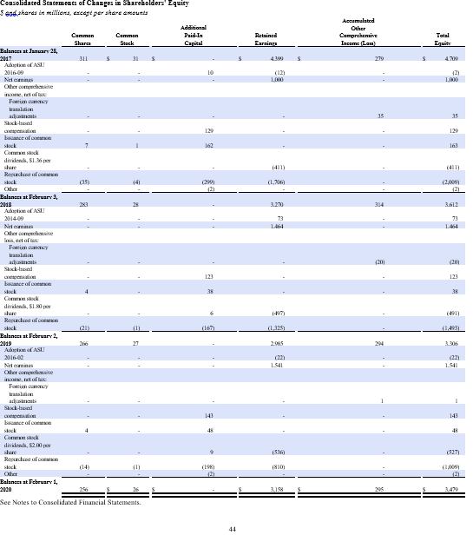

Attachment II

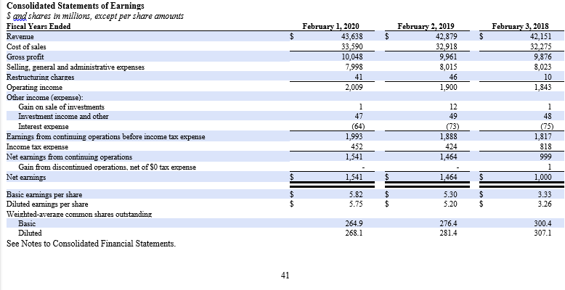

Attachment III

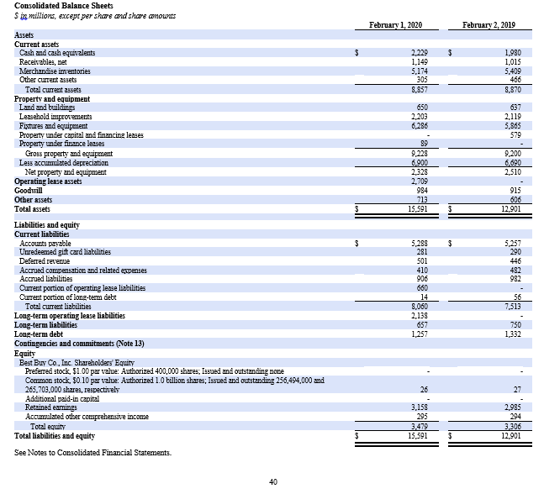

References:

Best Buy CO., INC. Form 10-K Annual Report. (2020, February 2) U.S. Securities and Exchange Commission (SEC) Retrieved from:
http://s2.q4cdn.com/785564492/files/doc_downloads/SEC_replacements/Best-Buy-Fiscal-2020-Form-10-K.pdf

